BARCLAY Top-down V-neck Baby Cardigan Jacket
Newborn
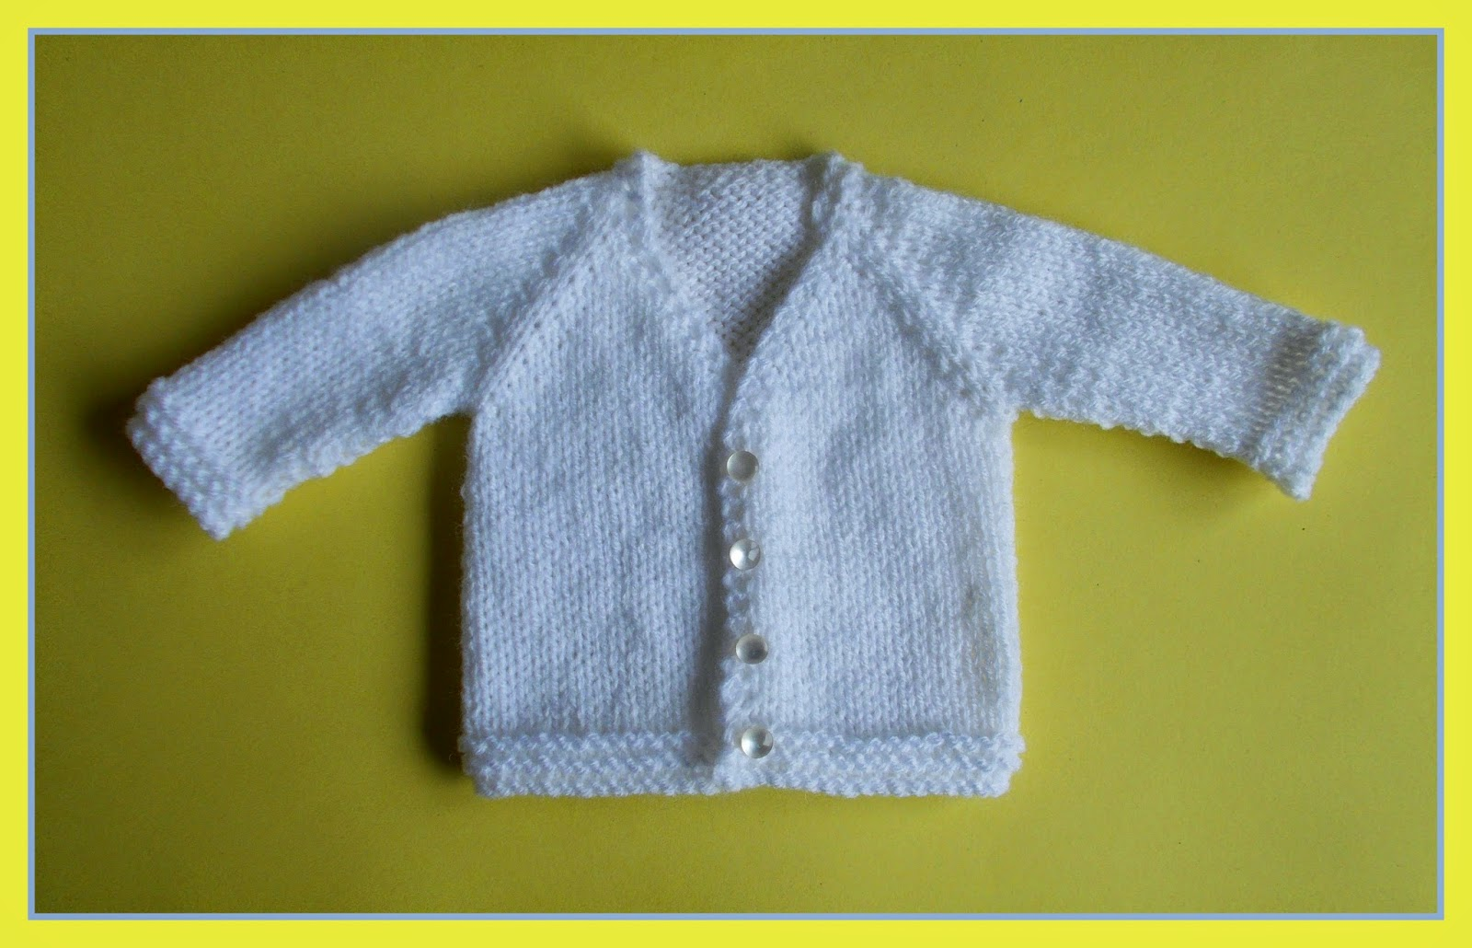

Size:
Width: 16"
Length: 8 ½ "
Sleeve Length: 5“
Tension:
22sts = 4" (10cm)
Requires:
DK (8ply) yarn for the long sleeved version
4mm needles
5 small buttons
Cast on 24sts
1st Row: K1, kfb, knit to last 3sts, kfb, k2 26sts
2nd Row S1, knit to end
3rd Row: S1, kfb, knit to last 3sts, kfb, k2 28sts
4th Row, and every alternate row S1, k1, purl to last 2 sts, k2
5th Row: S1, kfb, kfb, k1, kfb, k1, kfb, k13, kfb, k1, kfb, k1, kfb, kfb, k2 36sts
7th Row: S1, kfb, k1, kfb, k3, kfb, k1, kfb, k15, kfb, k1, kfb, k3, kfb, k1, kfb, k2 44sts
9th Row: S1, kfb, kfb, k1, kfb, k5, kfb, k1, kfb, k17, kfb, k1, kfb, k5, kfb, k1, kfb, kfb, k2 54sts
11th Row: S1, kfb, k2, kfb, k1, kfb, k7, kfb, k1, kfb, k19, kfb, k1, kfb, k7, kfb, k1, kfb, k2, kfb, k2 64sts
13th Row: S1, kfb, k4, kfb, k1, kfb, k9, kfb, k1, kfb, k21, kfb, k1, kfb, k9, kfb, k1, kfb, k4, kfb, k2 74sts
15th Row: S1, kfb, k6, kfb, k1, kfb, k11, kfb, k1, kfb, k23, kfb, k1, kfb, k11, kfb, k1, kfb, k6, kfb, k2 84sts
17th Row: S1, kfb, k8, kfb, k1, kfb, k13, kfb, k1, kfb, k25, kfb, k1, kfb, k13, kfb, k1, kfb, k8, kfb, k2 94ts
19th Row: S1, kfb, k10, kfb, k1, kfb, k15, kfb, k1, kfb, k27, kfb, k1, kfb, k15, kfb, k1, kfb, k10, kfb, k2 104sts
21st Row: S1, kfb, k12, kfb, k1, kfb, k17, kfb, k1, kfb, k29, kfb, k1, kfb, k17, kfb, k1, kfb, k12, kfb, k2 114sts
23rd Row: S1, kfb, k14, kfb, k1, kfb, k19, kfb, k1, kfb, k31, kfb, k1, kfb, k19, kfb, k1, kfb, k14, kfb, k2 124sts
25th Row: S1, kfb, k16, kfb, k1, kfb, k21, kfb, k1, kfb, k33, kfb, k1, kfb, k21, kfb, k1, kfb, k16, kfb, k2 134sts
27th Row: S1, kfb, k18, kfb, k1, kfb, k23, kfb, k1, kfb, k35, kfb, k1, kfb, k23, kfb, k1, kfb, k18, kfb, k2 144sts
29th Row: S1, k23, slip next 28sts on to a stitch holder for the sleeve, k40, slip next 28sts on to a stitch holder for the sleeve, k24 88sts
30th Row: S1, k1, purl to last 2 sts, k2

Body ~
1st Row: S1, k1, yrn, k2tog (makes a buttonhole), knit to end
2nd Row: S1, k1, purl to last 2 sts, k2
3rd Row: S1, knit to end
4th Row: S1, k1, purl to last 2 sts, k2
Repeat the last 2 rows twice more
Repeat the last 8 rows twice more
25th Row: S1, k1, yrn, k2tog (makes a buttonhole), knit to end
26th Row: S1, k1, purl to last 2 sts, k2
27th Row: S1, knit to end
28th Row: S1, k1, purl to last 2 sts, k2

Border ~
Knit 4 rows
33rd Row: S1, k1, yrn, k2tog (makes a buttonhole), knit to end
Knit 2 rows
Cast off knitwise

Short Sleeve Borders (both alike) ~

Put the 28sts, left on a stitch holder, back on to a knitting needle. Rejoin yarn.
Knit 7 rows
Cast off knitwise
Make the second sleeve in the same way
Sew up sleeve seams. Darn away ends
Add 5 small buttons

Long Sleeves ~ Both Alike
Put the 28sts, left on a stitch holder, back on to a knitting needle. Rejoin yarn
With right side facing –
1st Row: Kfb , knit to last st, kfb 30sts
Starting with a purl row, stocking stitch 7 rows
9th Row: K2tog, knit to last 2sts, k2tog 28sts
Starting with a purl row, stocking stitch 7 rows
Repeat the last 8 rows once more 26sts
Next Row: K2tog, knit to last 2sts, k2tog 24sts
Starting with a purl row, stocking stitch 3 rows
(You can adjust the sleeve length at this point)
Knit 7 rows
Cast off knitwise
Make the second sleeve in the same way
Sew up sleeve seams. Gather together underarms
Darn away ends

Sew on 5 small buttons

